Experiment 6.4
Determination and plotting of Capacitance vs Dielectric Constant (Glass)

Code File Name: Exp6_4_Capacitance_vs_DielectricConstant_Glass.m
Code
clc;
epsilon0 = 8.854e-12;
A = 1e-4;
d = 1e-3;
er = linspace(4,8,100);
C = (epsilon0 .* er .* A) ./ d;
plot(er,C,'LineWidth',2);
xlabel('Dielectric constant');
ylabel('Capacitance');
title('Capacitance vs dielectric constant (Glass)');
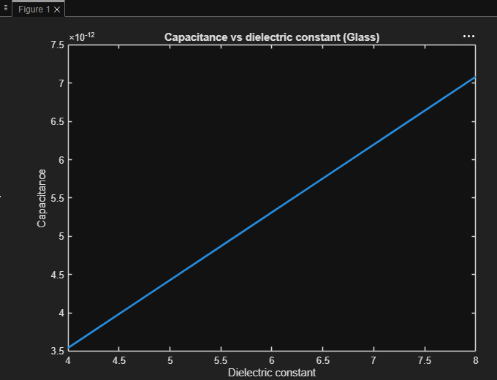
Output Graph

